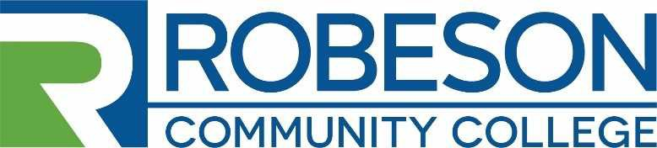
Human Resources Post Office Box 1420 Lumberton, NC 28359
910.272.3537

EMPLOYMENT OPPORTUNITY

VACANCY: PC Technician

REQUIREMENTS:
Minimum Qualifications: An associate degree in computer science or an information technology related field is recommended. Relevant certifications (e.g. CompTIA A+) will be an advantage.
Preferred Qualifications: An associate degree in a computer science related field and a minimum of two (2) years’ experience in an information technology field in a public or private setting.
DUTIES AND RESPONSIBILITIES: The incumbent will have the following duties & responsibilities:
- Able to work individually as well as part of a team on assigned tasks to ensure successful outcomes
- Perform troubleshooting and maintenance procedures
- Provide customer service and technical support for all departments
- Install, assemble, configure, and troubleshoot desktops, laptops, and related hardware
- Install and configure software
- Technical writing on repairs and fixes for future reference
- Research solutions to provide end user support.
- Perform other duties as necessary

SALARY: The salary will be determined in accordance with RCC’s Salary Plan and the applicants’ education and work experience. Salary range $36,715 to $49,630.

APPLICATION PROCEDURE:
Candidates for the position should complete an RCC Application for Employment and submit a Professional Resume, a photocopy of Official Transcripts, and any other supporting documentation related to the qualification requirements. Robeson Community College reserves the right to perform consumer background checks on applicants who are considered for employment and the College may administer personality profile testing as part of the selection process.

DEADLINE FOR APPLICATIONS: Friday, October 2, 2020 at 3:00 PM
PROPOSED DATE OF EMPLOYMENT: November 1, 2020

CONTACT: Human Resources – Sally Carr
Robeson Community College
P. O. Box 1420 Lumberton, NC 28359 910.272.3537 scarr@robeson.edu
RCC is an Equal Opportunity Employer

