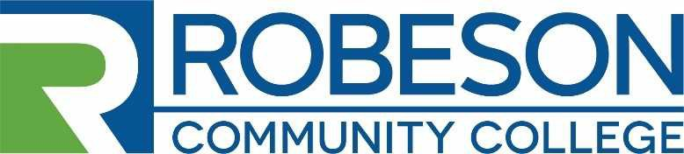
Human Resources Post Office Box 1420 Lumberton, NC 28359
910.272.3537

EMPLOYMENT OPPORTUNITY

VACANCY: Financial Aid Specialist/Veterans Affairs Certifying Official

REQUIREMENTS:
Minimum Qualifications: A minimum of a Bachelor’s degree from a regionally accredited institution; experience working in a college setting or any equivalent combination of training and experience which provides the required knowledge, skills, and abilities; working knowledge of computer programs; experience in delivering excellent and professional customer service, and the ability to effectively manage student aid programs.

Preferred Qualifications: Experience working with veterans and/or veteran educational benefits and in a financial aid office. Knowledge of Datatel/Colleague software or similar college software, document imaging systems, and MS Office software.

DUTIES AND RESPONSIBILITIES: The applicant will have the following duties & responsibilities:
- This position is equally split between Financial Aid Programs & Veteran Services (50% of time spent working on financial aid programs and 50% to veterans/military educational benefits).

- Coordinates and serves as the lead point of contact in the certification of the Veteran’s Administration educational benefits program

- Facilitates the enrollment and retention of all military, veterans, and dependents of service members by certifying VA educational benefits in a timely manner.

- Advises VA students on all factors that have a potential impact on VA educational benefits; including, but not limited to successful academic progress, credit hour requirements, changes to student schedule, and location of training or classes.

- Provides necessary correspondence to VA students regarding important information and updates to VA educational benefits, as well as changes to college processes and procedures.

- Inputs and updates military-connected student codes and information in Colleague and VA-Once system.

- Prepares and maintains required reports and documentation, in accordance with State Approving Agency (SAA) policy and audit guidelines.

- Counsels/advises students about financial aid eligibility, application procedures, aid programs, awarding policies, costs, billing process, indebtedness, and financial planning.

- Performs processes for applications, grant/scholarships, student employment, and SAP review; recalculates aid eligibility.

- Conducts thorough verification of student data provided on FAFSA application, reviews student files, and resolves conflicts and discrepancies in accordance to federal and state regulations.

- Maintains accurate, easily accessible records of all financial aid programs for auditing and evaluation purposes in accordance with FERPA and Higher Education Act privacy laws and guidelines.

- Processes financial aid awards, inputs data, assign account codes, makes adjusting entries, and balances assigned funds and accounts.

- Collects and maintains all required documents related to financial aid applications and VA/military records in a manner which is consistent, organized and meets all federal, state and institutional guidelines;

- Prepares applicable financial aid reports related to assigned area of responsibility.

- Actively promotes the availability and accessibility of financial aid programs and veteran/military educational benefits to the community.

- Represents the Financial Aid & Veteran Services Office during promotional events (Open Houses, Orientations, Workshops, etc.).

- Performs additional tasks or duties as assigned by the Director of Financial Aid & Veteran Services

- Interprets the mission, educational philosophy, and vision statements of Robeson Community College to the general public.

- Maintains the integrity of the College and its related foundations.

- Represents the College professionally and handling all financial affairs.

SALARY: The salary will be determined in accordance with RCC’s Salary Plan and the applicants’ education and work experience. Salary range $36,715 to $49,630.

APPLICATION PROCEDURE:
Candidates for the position should complete an RCC Application for Employment and submit a Professional Resume, a photocopy of Official Transcripts, and any other supporting documentation related to the qualification requirements. Robeson Community College reserves the right to perform consumer background checks on applicants who are considered for employment and the College may administer personality profile testing as part of the selection process.

DEADLINE FOR APPLICATIONS: Open Until Filled.

PROPOSED DATE OF EMPLOYMENT: December 1, 2020

CONTACT: Human Resources – Sally Carr
Robeson Community College
P. O. Box 1420 Lumberton, NC 28359 910.272.3537 scarr@robeson.edu

RCC is an Equal Opportunity Employer

