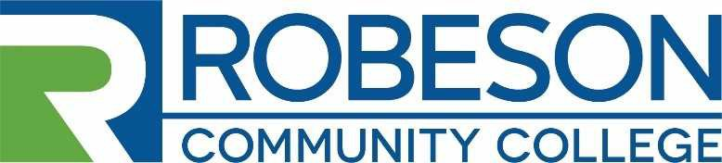
Human Resources Post Office Box 1420 Lumberton, NC 28359
910.272.3537

EMPLOYMENT OPPORTUNITY

VACANCY: Electrical / Electronics Instructor (NCDPS – Lumberton, NC)

REQUIREMENTS:
Minimum Qualifications: Electrical/Electronics Diploma and/or an associate degree from a regionally accredited institution with at least three (3) years’ experience in electrical/electronics or closely related field. Previous teaching experience in a prison setting is desired.

Preferred Qualifications: Bachelor's degree from a regionally accredited institution with at least three (3) years’ experience in Electrical/Electronics or closely related field. Previous teaching experience in a prison setting is desired.
Qualified candidates must be knowledgeable of all the rules and regulations mandated by the NC Department of Public Safety. Qualified candidates must have computer skills and have the knowledge to submit all required paperwork to the College. Be willing to accept responsibility for professional and personal growth, demonstrate evidence of flexibility and willingness to change, and have an open-mind and fairness towards other faculty, staff, and students.
DUTIES AND RESPONSIBILITIES: The applicant will have the following duties & responsibilities:
- Teach approved curriculum and all course work as outlined.
- Maintain supportive relationships with prison staff and other academic programs at the prison and the College.
- Assure the program meets standards established by the College and the Prison.
- Instructor will be expected to teach schedule as assigned by the director.
- Prepare and process course offerings and class schedules that meet program requiresments of the NC Department of Public Safety and the needs of the students.
- Teach a minimum of 30 to 35 contact hours weekly.
- Supervise instructional functions and student activities assigned in the classroom and lab.
- Register students and submit paperwork to the College appropriately.
- Ensure instructional resources are being utilized efficiently and effectively.
- Teach the curriculum with a focus on preparing students to enter the workforce.
- Provide instruction through non-traditional methods that employ a variety of techniques and simulations.
- Responsible for assisting with the overall operation of the Electrical/Electronics Program.
- Responsible for maintaining and submitting accurate audible records to the College.
- Attend and participate in any professional development offerings as assigned by the College and /or the departmenat of Public safety.
- Develop student learning outcomes to enhance student learning.
- Incorporate the College's general education outcomes into courses.
- Participate in program level assessment and planning.
- Serve on college committees as requested.
- Perform other duties as necessary.

SALARY: The salary will be determined in accordance with RCC’s Salary Plan and the applicants’ education and work experience. Salary range: $54,444 to $80,088.

APPLICATION PROCEDURE:
Candidates for the position should complete an RCC Application for Employment and submit a Professional Resume, a photocopy of Official Transcripts, and any other supporting documentation related to the qualification requirements. Robeson Community College reserves the right to perform consumer background checks on applicants who are considered for employment and the College may administer personality profile testing as part of the selection process.

DEADLINE FOR APPLICATIONS: Open Until Filled

PROPOSED DATE OF EMPLOYMENT: December 1, 2020(tentatively)

CONTACT: Human Resources – Sally Carr
Robeson Community College
P. O. Box 1420 Lumberton, NC 28359 910.272.3537 scarr@robeson.edu

RCC is an Equal Opportunity Employer

