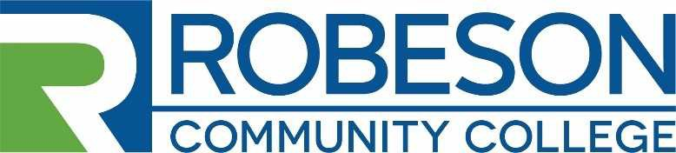
Human Resources Post Office Box 1420 Lumberton, NC 28359
910.272.3537

EMPLOYMENT OPPORTUNITY

VACANCY: EMS Clinical Coordinator (12 month)

REQUIREMENTS:

Minimum Qualifications: Associate of Applied Science in Emergency Medical Science or Related Field. A minimum of five (5) year’s work experience in Emergency Medical Services or related field and/or equivalent professional experience. North Carolina EMS Credentialed as a North Carolina Paramedic or as a National Registry Paramedic. Two years of experience teaching in post-secondary educational environment; or experience instructing students as a preceptor; or experience as a training officer. Advanced Cardiac Life Support (ACLS) instructor, Pediatric Advance Life Support (PALS), AHA CPR Instructor or ability to obtain certifications within one year of employment.

Preferred Qualifications: Baccalaureate degree, Level I or II Paramedic Instructor Certification.

Candidate must be knowledgeable of North Carolina Office of Emergency Medical Services (OEMS) rules and regulations and possess a valid Class C Driver’s License. Also, candidates should be familiar with Commission on Accreditation of Allied Health Education Programs (CAAHEP) Accreditation Criteria Standards and Guidelines for the Accreditation of Educational Programs in the Emergency Medical Services Professions and the Committee on Accreditation of Educational Programs for the Emergency Medical Services Professions Standards (CoAEMSP)

DUTIES AND RESPONSIBILITIES: The incumbent will have the following duties & responsibilities:
- Serve as EMS Curriculum (CU) Faculty.
- Plan, organize, promote and teach precertification EMS CU courses (class, lab and clinical) for the College day, evening, weekend and online as required.
- Provide placement, advising and follow-up support services for students.
- Assist in the preparation of students for licensure and certification.
- Implement and assess identified student learning outcomes.
- Maintain appropriate records for certifications, credentials and licenses.
- Foster meaningful relationships with internal and external partners to effectively carry out the purpose of the office.
- Facilitate workshops, seminars, and support services, as requested.
- Maintain communication with instructors from other divisions in order to keep courses up-to-date and appropriate.
- Perform all instruction-related duties in a timely manner and in accordance with the mission, policies and procedures of the College, the NCCCS and the North Carolina Office of EMS.
- Serve on department and college committees as requested.

SALARY: The salary will be determined in accordance with RCC’s Salary Plan and the applicants’ education and work experience.

APPLICATION PROCEDURE:
Candidates for the position should complete an RCC Application for Employment and submit a Professional Resume, a photocopy of Official Transcripts, and any other supporting documentation related to the qualification requirements. Robeson Community College reserves the right to perform consumer background checks on applicants who are considered for employment and the College may administer personality profile testing as part of the selection process.

DEADLINE FOR APPLICATIONS: Open Until Filled
PROPOSED DATE OF EMPLOYMENT: January 12, 2021

CONTACT: Human Resources – Sally Carr
Robeson Community College
P. O. Box 1420 Lumberton, NC 28358 910.272.3537
scarr@robeson.edu

RCC is an Equal Opportunity Employer

