Instructions to install MS Office from Microsoft Online Portal

Click on https://portal.office.com

Sign in using your school credentials (i.e yourusername@st.robeson.edu) and then tab to or click in the password box
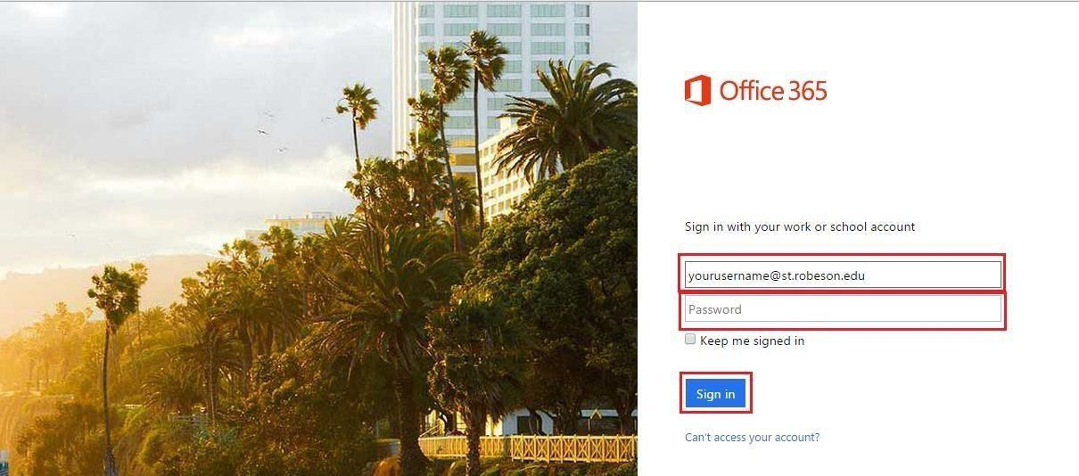

You will be redirected to the RCC site where you’ll enter your password
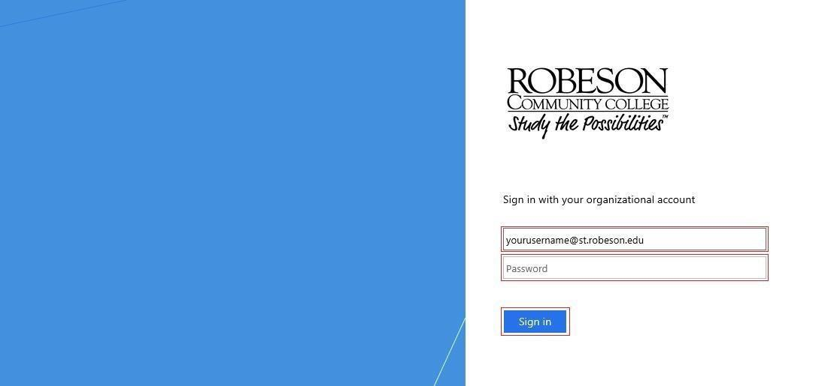

Click on the Gear near your name and picture in top right-hand corner.
After clicking Gear, drop-down appears. Click on Office 365.

Another window will open and you should click on Software.

After you click Software, the following window opens and you can click on Install.

