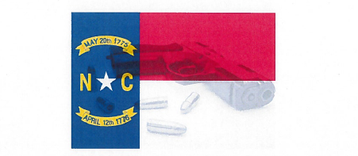
“North Carolina Concealed Carry Handgun Course”

Course Overview: This course will provide the student with a working knowledge of the North Carolina laws as they pertain to the Use of Deadly Force. This course also teaches the skills necessary to protect yourself and family members when faced with a violent encounter. The student will be taught the fundamentals of gun operations, gun safety, ammunition familiarization and shooting techniques. Proficiency with the weapon of your choice from the 3, 5, 7-yard lines are expected. This course is taught at Robeson Community College’s state of the art firearms facility, which utilizes a real time situational awareness moving target system, classroom and clean restrooms. For safety and instructional purposes, an instructor to student ratio will be met so as to allow more one on one personalized instruction.

Instructor: Deputy Chief Tommy Barnes, Lumberton Police Department

Target Audience: Must be 21 years old and have a state approved photo ID or Military ID.

Course Dates: This course will be offered on the following Saturdays:

January 30th | May 22nd | September 25th
February 27th | June 26th | October 23rd
March 27th | July 31st | November 20th
April 24th | August 28th | December 11th

Location: Robeson Community College Emergency Service Training Grounds
5825 S. Roberts Ave, Lumberton NC 28358
Course Hours: 8:00AM – 7:00PM (10 Hours)
Fee: $70.00
Equipment Required: Handgun, a box of (50 rounds) of ammunition. Eye/Ear protectors provided by the college.

Course Registration: Call (910) 272.3690 or email LET@Robeson.edu
www.robeson.edu/specialized-training-classes/
