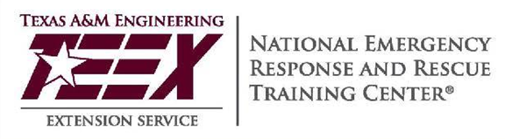

Hosted in conjunction with DHS/FEMA National Training Program, Texas A&M Engineering Extension Service (TEEX),Texas A&M University System
and the National Emergency Response and Recovery Training Center (NERRTC)
You are invited to Attend
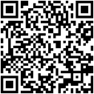
Date: February 24-25, 2027
Time: 8 am – 5 pm
Location: Robeson County EOC
Lumberton, NC 28358

FEMA Student ID Requirement

Prior to course delivery, all participants are required to establish a FEMA Student Identification Number (SID). This can be accomplished by registering at FEMA’s website. Participants must complete enrollment information through the TEEX student portal MGT317.

Recommended

Participants are also encouraged to have completed IS-100PWb, IS-200, IS-700 and IS-800. These courses can be found online at: http://training.fema.gov/IS/NIMS.aspx
Participant Audience:
• Emergency Management, Public Works Management, Utility Management
• Power Providers, Water Authorities, Utilities and Public Works Personnel
• Health Care and Hospital Management, Public Health Officials
• Local Emergency Personnel, Emergency Planning Directors & Managers, Emergency Preparedness Planning Personnel
• City Planning, Urban Development, Private Sector Stake holders
Topics:
• Threats to Public Services
• Disaster Mitigation
• Disaster Planning and Management
• Disaster Response and Recovery
• Public Information
MGT-317 Disaster Management for Public Services
Disaster Management for Public Services brings together planning and management officials who are expected to identify and mitigate hazards, and who plan and manage disaster response and recovery efforts or have emergency management roles within their jurisdictions. Public service stakeholders can extend their knowledge and skills for protecting their communities and critical infrastructure from potential or actual threats. During this course, participants work together in multidisciplinary teams to apply the course information with their professional experience in a variety of hands-on, small group activities, and disaster scenarios.
Registration is free! Please Contact: ______Steven West_____
Phone: ___ 910.272.3329___ Email: _____swest@robeson.edu____

