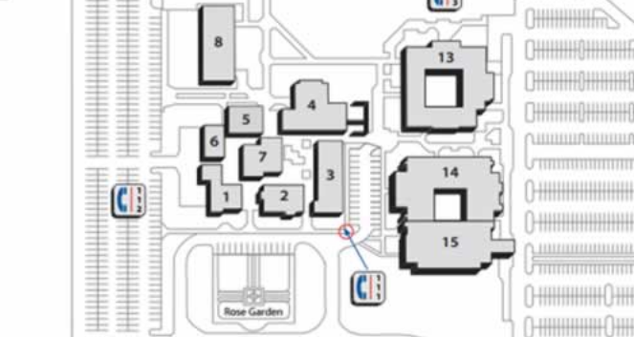

@RobesonCC

Submitting Documents and Forms During COVID-19

Due to COVID-19, in-person visits to campus are not allowed at this time. **To submit required financial aid forms and documentation, please use one of the following options below:**

**CAMPUS DROPBOX:** Students may drop off forms and documents to a designated, locked drop box located in the front of the campus beside the President’s Office, Building 2 & 3. *Forms must be placed in an envelope, sealed, and have “****Financial Aid****” written on the envelope*.

**EMAIL:** Forms can be **attached** and submitted via an encrypted email using your RCC student email account **only**. Before sending the email, click on the “***Encrypt Message***” option in the right-hand side of the message window and turn on encryption.

**FAX:** 910-272-3314

**MAIL:** Robeson Community College, Attn: Financial Aid Office, P.O. Box 1460, Lumberton, NC 28359

For more information, visit **robeson.edu/fa**, contact us at 910-272-3352, or email finaid@robeson.edu