Drop Form
- Go to the e-forms website. Either navigate to the www.robeson.edu website and use the quick links menu to click on e-forms, or just go to the address bar and type in info.robeson.edu.
- You can login with your campus username and password. Please be sure to NOT use put a win\ in front of your username.
- When you log in, you should have a few options on the portal page.
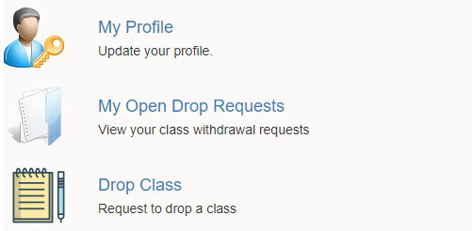
My Profile – is to update your account profile info if you need to
My Open Drop Requests – will show any drop forms that you have initiated
Drop Class – This is the option as an instructor or student to actually initiate a Drop Form
- Students - the Drop Class form will immediately pull your class information for this semester based on the information tied to your e-forms login account.
NOTE – it may take 40 seconds or so, for it to pull back your class schedule
Instructors - it will ask for a Student ID number (Please note this has to have all 7 digits)
It will also, ask for the semester (it should default to the current semester) then it will pull back the course info for the student on that semester.
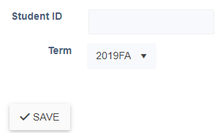
- Highlight the course you would like to drop and click on the continue button.
Students - This will take you to the drop form itself, and allow you to choose the reason for the drop, and sign at the bottom of the form.
Instructors – This will take you to the drop form itself, and allow you to choose the reason for the drop, pass/fail, grade at time of drop, official drop date, last date attended class, and sign the bottom of the form. The Instructor form does not need a student signature, but does require an instructor/advisor signature.
- Click save at the bottom of the form. This will move it to the next step in the process. Students -> Instructors -> Records and Registration. If you initiated the drop you will be able to see where it is in the process with the My Open Drop Requests section of the portal.

