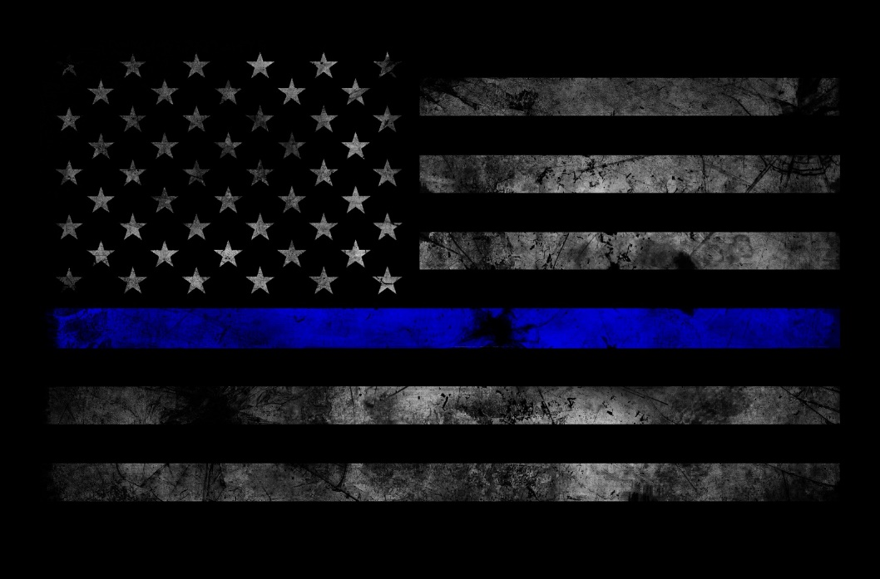 ­­

https://www.robeson.edu/law/

***Robeson Community College- “A leader in training our law enforcement professionals”***

Robeson Community College

Law Enforcement Training Division

presents:

**“Being Prepared for the Day”**

**Surviving an Officer Involved Encounter**

**Program Overview:** Being in an Officer-involved shooting or critical incident produces uncertainties, stress and fears of what will happen next. Undue anxiety can develop within both personal and professional relationships and effect job performance and home life. This 16-hour class, Being Prepared for the Day, is for the officer who wants to better understand the dynamics of a deadly force encounter and to prepare themselves for that day.

“Being Prepared for the Day” offers an in-depth analysis of what occurs during and after an officer-involved shooting along with information to better prepare you before the incident can happen.

**Instructor:** Eddy Summers is a 33-year veteran of law enforcement and retiree of the Greensboro Police Department.

**Target Audience:** Sworn Law Enforcement Officers

**Fees**: No cost to Law Enforcement Personnel

**DATE:** October 21-22, 2020  
**TIME:** 8:30 a.m. – 5:30 p.m.   
**LOCATION:** Sammy Cox Law Enforcement Training Center (Building 11) 5160 Fayetteville Road Lumberton, North Carolina 28360

To register email: [LET@robeson.edu](mailto:LET@robeson.edu) or call Johnny Coleman (910) 272-3650

