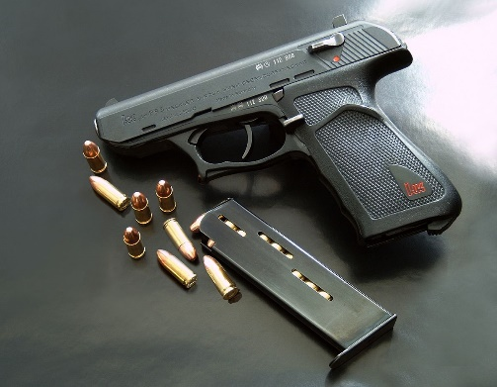

“Basic Firearms Handling Course”

Basic Firearms Course – This course will provide students with a basic working knowledge of handgun safety, handling and operability. Students will be taught basic gun safety rules and receive hands-on instruction in safe gun handling, marksmanship, cleaning, and storage of their handgun. Students will also learn basic firearms nomenclature, cycle of operation, and a basic knowledge of ammunition. Students will have the opportunity to dry fire and live fire their handgun. Students will have to provide their own handgun and ammo. All instruction is provided under the supervision of a certified firearms instructor. This course is taught at Robeson Community College’s state of the art facility with a classroom and clean restrooms. For safety and instructional purposes, an instructor to student ratio will be met to allow more one on one personalized instruction.

Instructor: Deputy Chief Tommy Barnes, Lumberton Police Department

Target Audience: Must be 21 years old and have a state approved photo ID or Military ID.

Course Dates: This course will be offered on the following Saturdays:

January 23rd | July 24th
March 20th | September 18th
May 15th | November 13th

Location: Robeson Community College Emergency Service Training Grounds
5825 S. Roberts Ave, Lumberton NC 28358
Course Hours: 9:00AM – 6:00PM (8 Hours)
Fee: $70.00 (If CCW Class taken within same year, rec. $ 20.00 Disc. On Registration for CCW)
Equipment Required: Handgun, a box of (100 rounds) of ammunition. Eye/Ear protectors provided by the college.

Course Registration: Call (910) 272.3690 or email LET@Robeson.edu
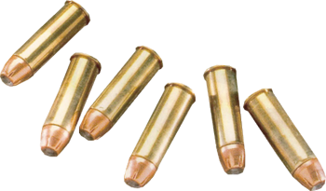

www.robeson.edu/specialized-training-classes/

