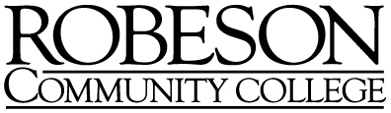

Job Description

TITLE:
Adjunct Faculty SPANISH

FUNCTION:
Adjunct faculty are professional educators with the primary responsibility of providing a quality learning experience for all Robeson Community College students. Adjunct Faculty are responsible for planning, organizing, promoting, and teaching appropriate courses for Robeson Community College. Adjunct Faculty are expected to perform all instruction-related duties in a timely manner and in accordance with the mission, policies, and procedures of the College, the North Carolina Community College System, and with appropriate accrediting entities where applicable.

RELATIONSHIPS:
The adjunct faculty member reports to the appropriate Department Chair or Program Director.

DUTIES AND RESPONSIBILITIES:
- Teach curriculum level Spanish courses
- Teach classes day and/or evening, Internet and/or hybrid courses
- Assess student learning within each course being taught
- Incorporate the college’s general education outcomes into the courses being taught

REQUIREMENTS:
Preferred Qualifications: A Master of Arts in Spanish from a regionally accredited institution.
Minimum Qualifications: A Master’s Degree with 18 hours in Spanish from a regionally accredited institution.

Applicant Documents:
Required Documents
- Resume
- Cover Letter
- Unofficial Transcripts
Optional Documents
- Certification

