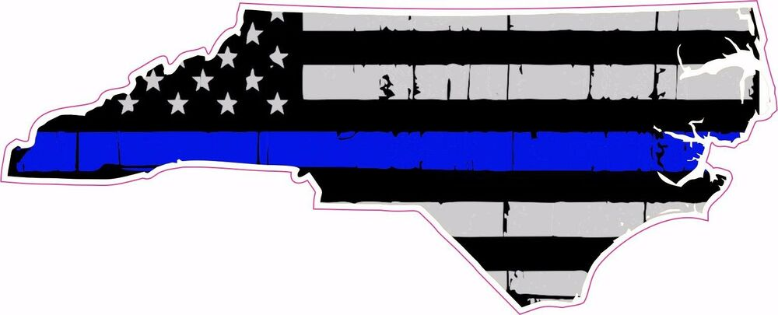

***LAW ENFORCEMENT TRAINING CENTER***

**Police Law Institute**

***Approved For Credit by the North Carolina Justice Academy*** **Andrew Tallmer, Esq., Instructor**

**Date / Time:** July 20-31, 20208:00a -5:00p

**Location:** Robeson Community College, Building 9 (Room 901)

5160 Fayetteville Rd., Lumberton, N.C. (Exit 22 & I-95)

PLEASE BRING A LAPTOP TO CLASS

**Class will begin at 8:00 a.m.** The text for this course is **Arrest, Search and Investigation 5th Edition**, by Robert L. Farb (Institute of Government: 2016) **and the latest supplement**. This text is referred to extensively throughout the course. **IT IS A REQUIREMENT THAT EACH STUDENT HAVE A COPY OF THESE TEXTS AVAILABLE TO HIM OR HER FOR THE DURATION OF THE CLASS. STUDENTS MUST HAVE THE FIFTH EDITION, NOT AN EARLIER EDITION. STUDENTS MUST ALSO HAVE THE “RED” AND “GREEN” PLI BOOKS. THESE TEXTS ARE AVAILABLE FROM THE NCJA BOOKSTORE, 910-525-4151.**

The Farb book is available from the NCJA bookstore, as are the PLI “Red” and “Green” books. Please contact the Academy Bookstore at (910) 525-4151, Ext. 310; or the Institute of Government Publication Office at (919) 966-4119, to place an order. Note that the Institute of Government sells only the Farb book, not the green and red books. The green and red books must be purchased from the NCJA Bookstore.

**YOUR AGENCY CAN BE BILLED FOR THE BOOKS BUT MUST HAVE AN ACCOUNT WITH THE JUSTICE ACADEMY’S BOOKSTORE. PLEASE CALL TO SET UP THE ACCOUNT. NO MONEY WILL BE EXCHANGED IN THE CLASSROOM.**

Students may wish to consider purchasing this book for yourself, not only to facilitate your progress in the course but for future use. Having your own copy allows you to highlight, underline and make notes during PLI instruction; in addition, the book is an invaluable tool for all law enforcement officers in the course of daily duties.

Be sure to bring pens, pencils, highlighters, and note paper.

**Course Registration:** Contact Johnny Coleman at (910) 272-3651 or email [jcoleman@robeson.edu](mailto:jcoleman@robeson.edu)

**Fee:** Exempt to Sworn Law Enforcement Officers

----------------------------------------------------------------------------------------------------------------------------------------------------

 Follow us on Facebook @ <https://facebook.com/rcclet>

**ROBESON COMMUNITY COLLEGE “*A leader in training our law enforcement professionals*”**