Wireless connection settings –Apple Device (iOS9)
- Click on the settings button on your Apple device.

- Select Wi-Fi on the left hand of the screen, and make sure Wi-Fi is enabled.
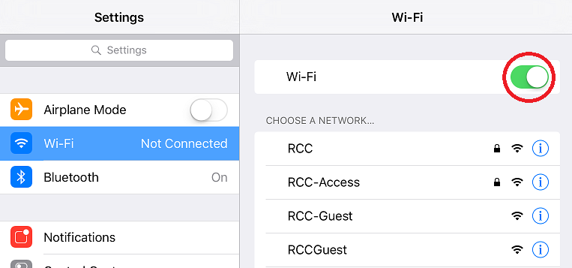

- Enter your username and password exactly like you would to log into Moodle. Once you enter the information, the Join text will turn blue, and you can click on it, to continue.
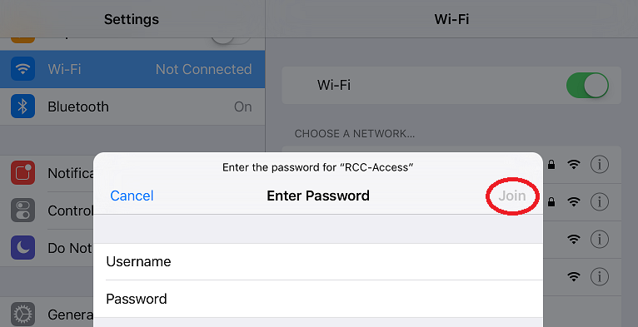
- Once you click the Join text, you should see a certificate window next. Click on the blue trust text in the top right hand corner, to continue connecting to campus Wi-Fi.
- RCC-Guest Wi-Fi will not require the username and password information, and is intended for those guests on campus that need access to the internet, but not to campus resources like Moodle, WebAdvisor, Email etc.

