Bring your own device (Windows 8, 8.1, and 10)
- Click on the wireless icon in the System Tray
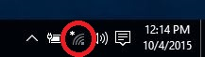
- Click on RCC-Access and click the Connect button
- Enter your username and password information. (The same as you use to log into Moodle)
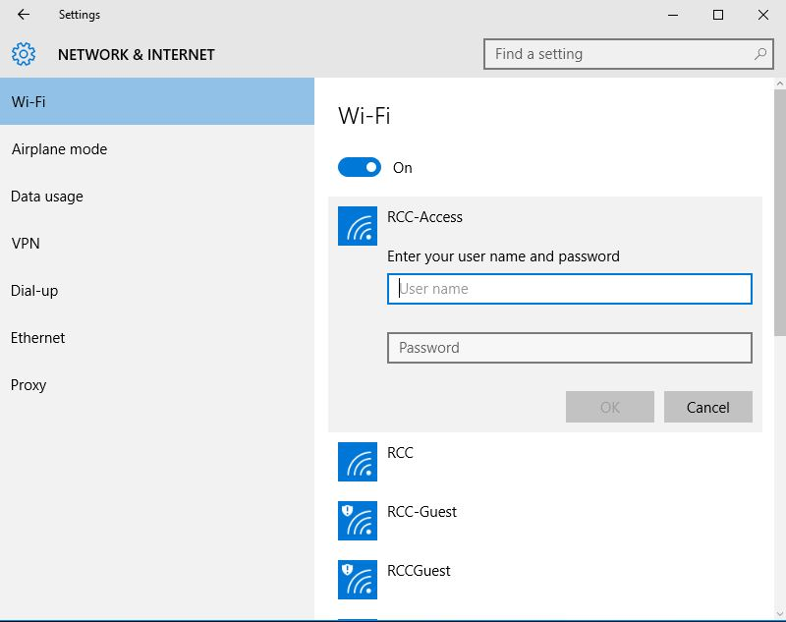
- If it prompts to accept the certificate click the Connect button, and it will continue.
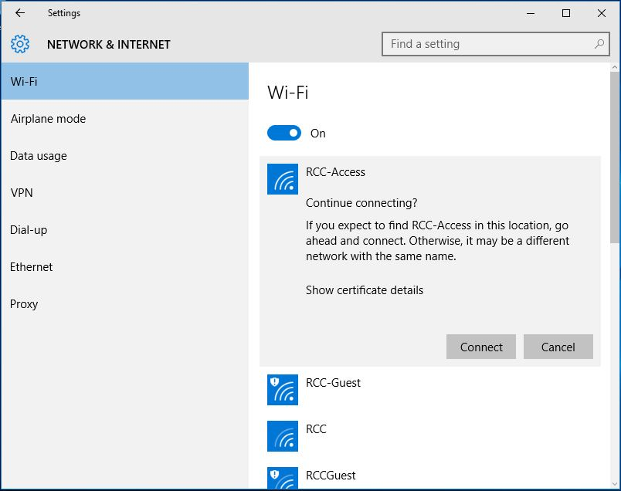
If you follow these steps and are still unable to connect please contact the IT help desk.

