Bring your own device settings (Windows 7 and older)
- Click on the wireless icon in the System Tray
- Click on Open Network and Sharing Center.
- Click on Connect to a network
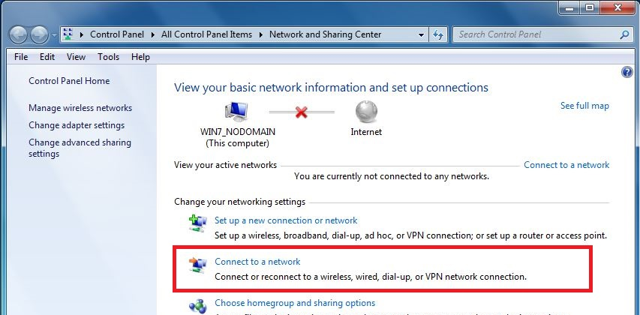
- Choose Manually connect to a wireless network, and click Next.
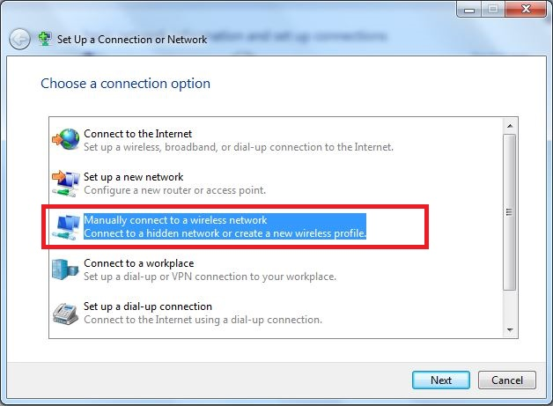
- Enter your manual network settings, an then click Next.
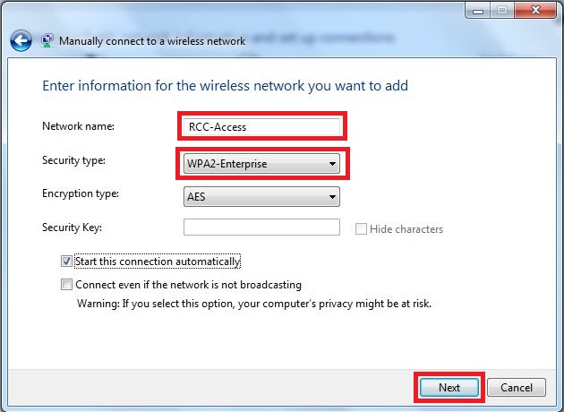

- Once your network has been created, click on Change connection settings.
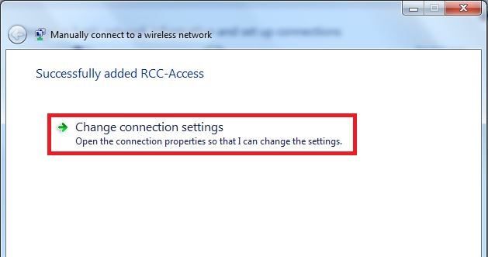
- You will need to make changes to each of these options. Start with Settings. ***Notice there are two places to change under the settings button (labeled “a” and “b”) and one final change under advanced settings (labeled “c”).***
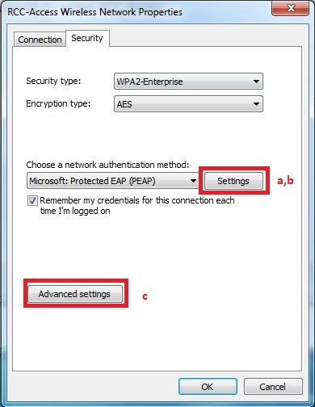
  - When you click on Settings. Make sure Validate server certificate is checked then click Configure.
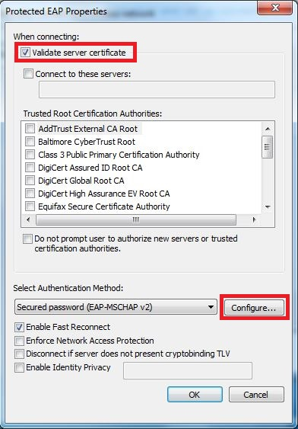

  - If this is your personal laptop make sure this is unchecked.
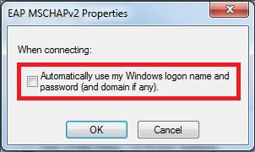
Click the OK button, then again on the previous window. This will take you back to the first images for Step 7. Click on the Advanced Settings button.
  - Make sure the settings are as below, and click OK. And then OK, on the previous window.
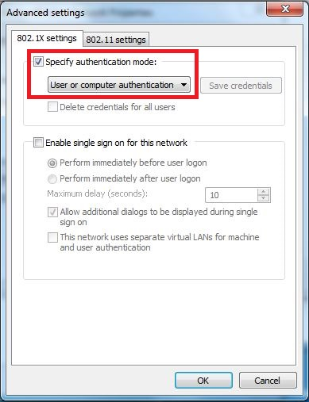

- Now click on your wireless connection icon, select RCC-Access and click connect.

- Enter your username and password the same as you use to log into Moodle.
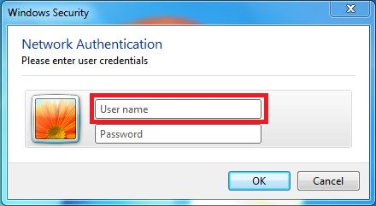
- If you get a security certificate error message just click on Connect.
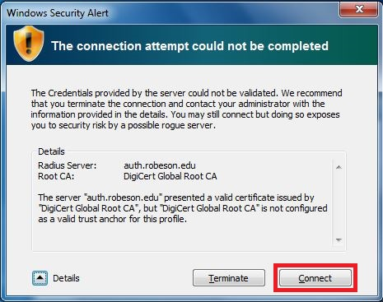
If you follow these steps and are still unable to connect please contact the IT help desk.

