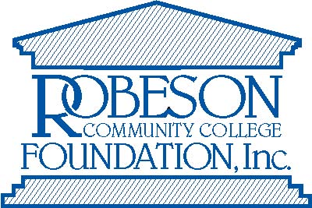

Request for Program Funds
Use this form to request a distribution from your Program Fund account. You must fill out one distribution form for each individual payee, and need to indicate the exact amount of the distribution requested. Submit this form along with any necessary documentation (invoice, receipts, institutional trip request forms, etc.).
____________________________________________________________________________

Name of Program Fund: ______________________________ Amount Requested: _________

Name & Address of Payee: ______________________________________________________

____________________________________________________________________________
Please give a brief description on why this disbursement is needed and how it benefits the institution: ___________________________________________________________________

____________________________________________________________________________

____________________________________________________________________________

____________________________________________________________________________

____________________________________________________________________________
The Robeson Community College Foundation, Inc. is a nonprofit corporation which receives, holds, invests and disburses funds for the purpose of providing scholarships to students. The foundation was organized in 1985 as a 501(c) (3) Corporation, creating an opportunity for the community to invest in the future of the College and its students. All contributions are tax deductible. By signing this form, the requestor agrees to utilize all funds in such a way that will benefit the institution and will NOT benefit the individual(s) personally who contribute to this fund.
Signature of Requestor: ___________________________________ Date: _______________
Signature of Supervisor: ___________________________________ Date: _______________
Return Form to the RCC Foundation
____________________________________________________________________________
FOR OFFICE USE ONLY:
Approved Amount: $______________
Signature of Foundation Director: ___________________________________ Date: ________________

