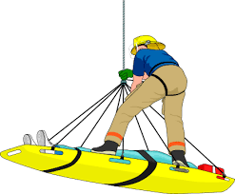

Technical Rescuer Daytime Academy
Robeson Community College Emergency Services Training Center

Technical Rescuer NFPA 1006 2013 Edition

August 1 Rescue Operations
August 2-3 Anchors and Mechanical Advantage
August 4 Fixed Ropes
August 5 Health and Wellness
August 8 Helicopter Transport
August 9-10 Horizontal Systems
August 10-11 Lowers and Raises
August 12 Personal Protective Equipment
August 15 Rescue Equipment
August 16 Rope Basics
August 17-18 Victim Management

Total hours 109

Technical Rescuer Vehicle NFPA 1006 2013 Edition

August 22 Rescue Operations
August 23 Vehicle Anatomy
August 24 Stabilization and Extrication
August 25 Large Vehicle Rescue
August 26 Victim Management

Total hours 43

All classes will be held at the emergency services training center and start at 0900 hrs. each day. Pre-registration is required. Call 910-738-7128.

