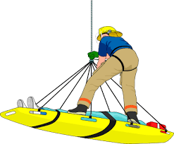

Technical Rescuer Ropes Saturday Academy
Robeson Community College Emergency Services Training Center

Technical Rescuer Ropes NFPA 1006 2008 Edition

October 8 TR Ropes Rescue Operations
October 8 TR Ropes Mechanical Advantages (Class starts at 2pm)
October 15 TR Ropes Anchors
October 22 TR Ropes Fixed Rope Systems
October 29 TR Ropes Lowers and Raises
November 5 TR Ropes Highlines
November 12 TR Ropes Victim Management

Total hours 59

This academy for those persons who are technical rescue certified under the 2008 standard. Successful completion of this course will upgrade students to technical rescuer certification under the new 2013 standard.

This opportunity will sunset December 31, 2017. Persons wishing to become technical rescuer certified after that date will have to take the full series of classes under the new standard.

Students are required to bring ropes PPE for each day of class. Each class is open enrollment.

All classes will be held at the emergency services training center and start at 0800 hrs. each day. Pre-registration is required. Call 910-738-7128.

