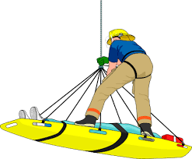

Technical Rescuer Daytime Academy
Robeson Community College Emergency Services Training Center

Technical Rescuer NFPA 1006 2013 Edition

April 3 Health and Wellness 8 hours
April 4 Rescue Operations 9 hours
April 5 Personal Protective Equipment 9 hours
April 6 Rescue Equipment 8 hours
April 7 Helicopter Transport 6 hours
April 10-11 Rope Basics 12 hours
April 12-13 Anchors & Mechanical Advantage 15 hours
April 17 Fixed Ropes 12 hours
April 18 Horizontal Systems 12 hours
April 19 Lowers & Raises 12 hours
April 20-21 Victim Management 16 hours

Technical Rescuer Vehicle NFPA 1006 2013 Edition

April 24 Rescue Operations 9 hours
April 25 Vehicle Anatomy 9 hours
April 26 Stabilization and Extrication 12 hours
April 27 Large Vehicle Rescue 6 hours
April 28 Victim Management 12 hours

Total hours for certification 167 hours

All classes will be held at the emergency services training center and start at 0900 hrs. each day. Pre-registration is required. Call 910-272-3330 or use our pre-registration link at www.robeson.edu/fireedu.

