Robeson Community College BYOD Settings Draft
- Click on the wireless icon in the Task Bar
- Click on Open Network and Sharing Center
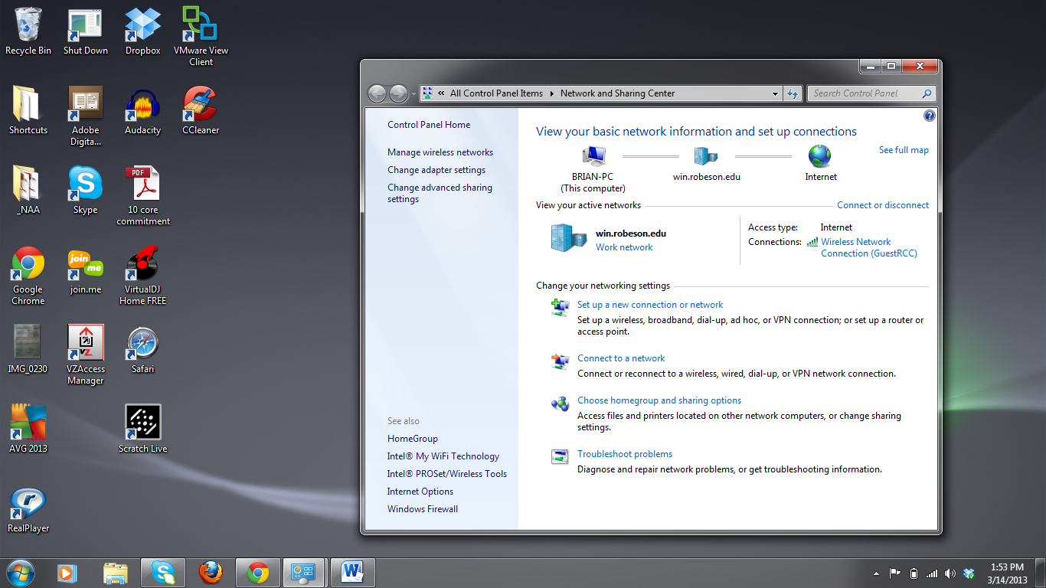

- Click on Manage wireless networks
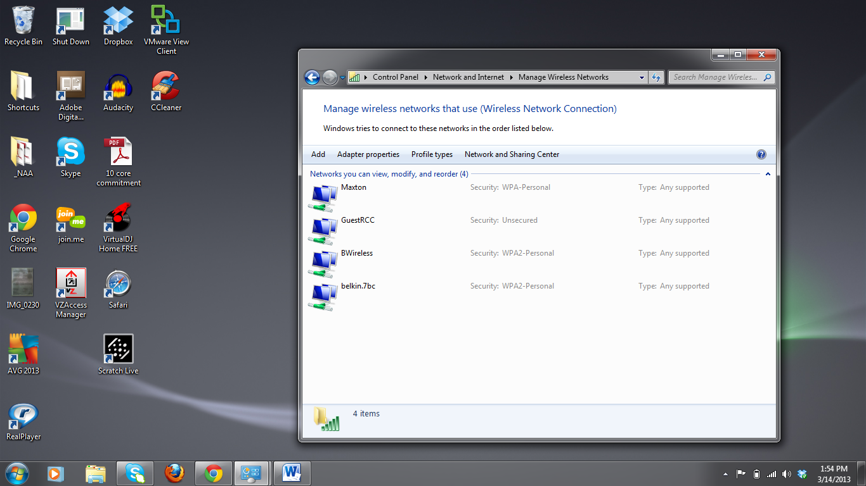
- Click on Add
- Click on Manually create network profile

- Fill in form as follows and click Next
- Verify connection was created and click Change connection settings
- The Wireless Network Properties box should pop up
- Click on the Security tab
- Click on Settings and uncheck the boxes at the top and ensure that the “Do not prompt user” box is unchecked, click on Configure
- Uncheck the “When connecting” box, click OK
- Uncheck the “Remember my credentials” box and click on Advance Settings
- Check the “Specify authentication mode” box and select User authentication from the drop-down menu. Click OK, and click OK
- Click on the wireless icon on the Task Bar, locate the “RCC” profile you just created
- Click on the new profile and click Connect

- Enter your Network Credentials and click OK
- Success, you should be connected at this time

If you follow these steps and are still unable to connect please contact the IT help desk.

