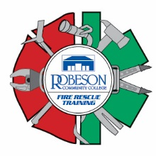

Firefighter Daytime Fall Academy
Robeson Community College Emergency Services Training Center
5825 NC72 East, Lumberton, N.C. 28358

Schedule of Classes

September 12-13 Orientation and Safety
September 14-15 Alarms and Communications
September 16 Fire Behavior
September 19 Portable Extinguishers
September 20-21 Personal Protective Equipment
September 22-23 Forcible Entry
September 26-27 Ventilation
September 28 Ropes
September 29-30 Ladders
October 3-4 Fire Hose Streams and Appliances
October 5 Foam Fire Streams
October 6-7 Loss Control
October 10 Emergency Medical Care
October 11-12 Rescue
October 13-14 Water Supplies
October 17-18 Sprinklers
October 19 Fire and Life Safety
October 20-21 Building Construction
October 24 Health and Wellness
October 25-26 Safety and Survival
October 27 Mayday
October 31-Nov. 3 Fire Control
November 4 Traffic Incident Management
November 7-10 Level 1 Hazardous Materials Responder

All classes start at 0900 hours and will be held at the Emergency Services Training Center. Pre-registration is required. Please call Robert or Tammy at the training center at 910-738-7128.

