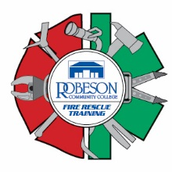

Firefighter Daytime Fall Academy
Robeson Community College Emergency Services Training Center
5825 NC72 East, Lumberton, N.C. 28358

REVISED Schedule of Classes

September 12-13 Orientation and Safety
September 14-15 Alarms and Communications
September 16 Fire Behavior
September 19 Portable Extinguishers
September 20-21 Personal Protective Equipment
September 22-23 Forcible Entry
September 26-27 Ventilation
September 29-30 Ladders
October 3-4 Fire Hose Streams and Appliances
October 5 Foam Fire Streams
October 6-7 Loss Control
October 20-21 Building Construction
October 24 Health and Wellness
October 25-26 Safety and Survival
October 27 Mayday
*October 31 Emergency Medical Care
*November 1-2 Rescue
*November 3-4 Water Supplies
*November 7-8 Sprinklers
*November 9 Ropes
*November 10 Traffic Incident Management
*November 11 Fire and Life Safety
*November 14-18 Level 1 Hazardous Materials Responder
*November 28-Dec. 1 Fire Control

*denotes schedule change due to college closing for Hurricane Matthew.

All classes start at 0900 hours and will be held at the Emergency Services Training Center. Pre-registration is required. Please call Robert or Tammy at the training center at 910-738-7128.

