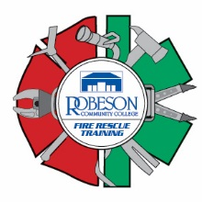

Firefighter Daytime Fall Academy
Robeson Community College Emergency Services Training Center
676 South Roberts Avenue, Lumberton, N.C. 28358

Schedule of Classes

March 6-7 Orientation and Safety
March 8-9 Personal Protective Equipment
March 10 Fire Behavior
March 13-14 Alarms and Communications
March 15 Portable Extinguishers
March 16-17 Forcible Entry
March 20-21 Ventilation
March 22 Ropes
March 23-24 Ladders
March 27-28 Fire Hose Streams and Appliances
March 29 Foam Fire Streams
March 30-31 Loss Control
April 3 Emergency Medical Care
April 4-5 Rescue
April 6-7 Water Supplies
April 10-11 Sprinklers
April 12 Fire and Life Safety
April 13-14 Building Construction
April 18-19 Safety and Survival
April 20 Mayday
April 21 Health and Wellness
April 24-27 Fire Control
April 28 Traffic Incident Management
May 1-5 Level 1 Hazardous Material Responder
May 8-10 Emergency Vehicle Operator

All classes start at 0900 hours and will be held at the Emergency Services Training Center. Pre-registration is required. Please call Robert or Tammy at the training center at 910-272-3330.

