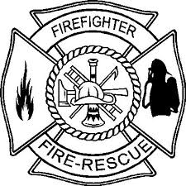

Firefighter Daytime Academy
Robeson Community College Emergency Services Training Center

April 4-5 Orientation and Safety
April 6-7 Alarms and Communications
April 8 Fire Behavior
April 11 Portable Extinguishers
April 12-13 Personal Protective Equipment
April 14-15 Forcible Entry
April 18-19 Ventilation
April 20 Ropes
April 21-22 Ladders
April 25-26 Fire Hose Streams and Appliances
April 27 Foam Fire Streams
April 28-29 Loss Control
May 2 Emergency Medical Care
May 3-4 Rescue
May 5-6 Water Supplies
May 9-10 Sprinklers
May 11 Fire and Life Safety
May 12-13 Building Construction
May 16 Health and Wellness
May 17-18 Safety and Survival
May 19 Mayday
May 23-26 Fire Control
May 27 Traffic Incident Management
May 31-June 3 Level 1 Hazardous Materials Responder

All classes start at 0900 hours and will be held at the Emergency Services Training Center. Pre-registration is required. Please call Robert or Tammy at the training center at 910-738-7128.

